Report of the Week

**Board Flashing**

In order to prepare the *Canoe* set up with the AVM, it was planned for this week to reflash my LG board. This, to switch from *p.car* to *android q*

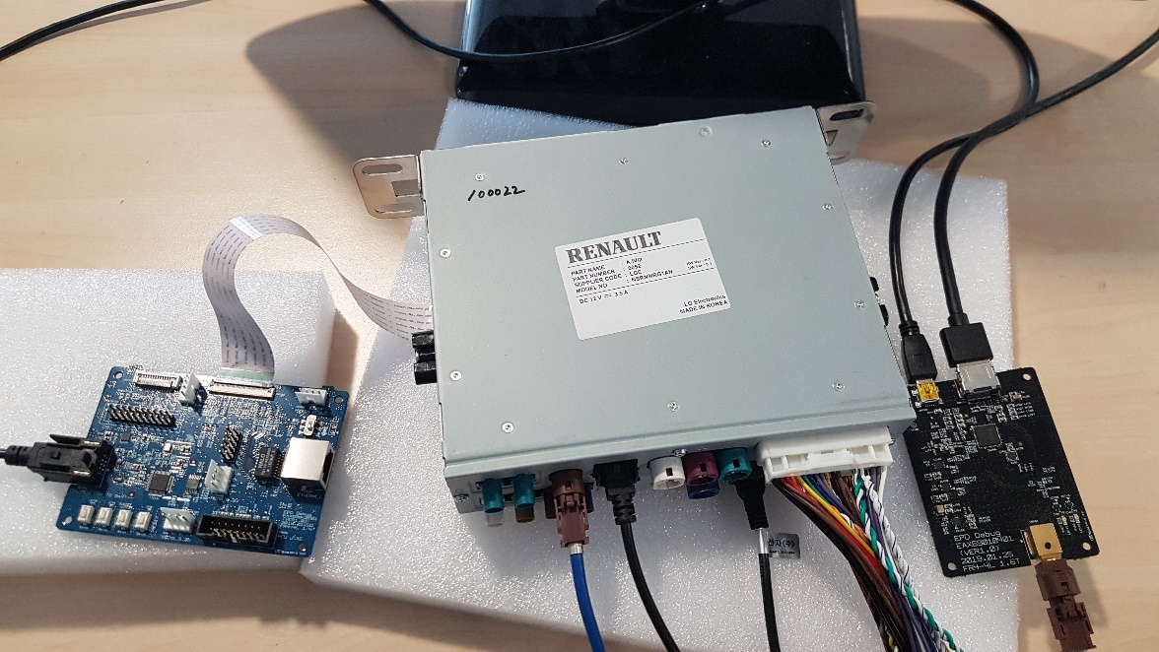

For that, I started by creating my own build like last week but this time, it is a build for the android q so it was necessary to change the branch for the *repo init*. For this, I take the following repo init

[**https://gitlabee.dt.renault.com/swlabs/cc/ivi/android/product/loire/manifest**](https://gitlabee.dt.renault.com/swlabs/cc/ivi/android/product/loire/manifest) **-b release_aivi2_03.05.30.Q0M.sit -m default.xml**

